Supplier Requirements

Marine

Revision 1.2

25th October 2018

Edition 3



**Table of Contents**

REVISION SUMMARY/ RATIONALE 4

FOREWORD 4

INTENDED APPLICATION 4

INTRODUCTION 4

0.1 General 4

0.2 Quality Management Principles 4

0.3 Process Approach 4

0.3.1 General 4

0.3.2 Plan-Do-Check-Act Cycle 4

0.3.3 Risk Based Thinking 4

0.4 Relationship with Other Management System Standards 4

1 SCOPE 5

2 NORMATIVE REFERENCES 5

3 TERMS AND DEFINITIONS 5

4 CONTEXT OF THE ORGANISATION 5

4.1 Understanding the Organisation and its Context 5

4.2 Understanding the Needs and Expectations of Interested Parties 5

4.3 Determining the Scope of the Quality Management System 5

4.4 Quality Management System and its Processes 5

5 LEADERSHIP 5

5.1 Leadership and Commitment 5

5.1.1 General 5

5.1.2 Customer Focus 5

5.2 Policy 5

5.2.1 Establishing the Quality Policy 5

5.2.2 Communicating the Quality Policy 5

5.3 Organisational Roles, Responsibilities and Authorities 5

6 PLANNING 6

6.1 Actions to Address Risks and Opportunities 6

6.2 Quality Objectives and Planning to Achieve Them 6

6.3 Planning of Changes 6

7 SUPPORT 6

7.1 Resources 6

7.1.1 General 6

7.1.2 People 6

7.1.3 Infrastructure 6

7.1.4 Environment for the Operation of Processes 7

7.1.5 Monitoring and Measuring Resources 7

7.1.6 Organisational Knowledge 7

7.2 Competence 7

7.3 Awareness 7

7.4 Communication 7

7.5 Documented information 7

7.5.1 General 8

7.5.2 Creating and Updating 8

7.5.3 Control of Documented Information 8

8 OPERATION 8

8.1 Operational Planning and Control 8

8.1.1 Product Safety 8

8.1.2 Prevention of Counterfeit Parts 9

8.2 Requirements for Products and Services 9

8.2.1 Customer Communication 9

8.2.2 Determining the Requirements Related to Products and Services 9

8.2.3 Review of Requirements Related to Products and Services 9

8.2.4 Changes to Requirements for Products and Services 9

8.3 Design and Development of Products and Services 9

8.3.1 General 9

8.3.2 Design and Development Planning 9

8.3.3 Design and Development Inputs 9

8.3.4 Design and Development Controls 9

8.3.5 Design and Development Outputs 9

8.3.6 Design and Development Changes 9

8.4 Control of Externally Provided Processes, Products and Services 9

8.4.1 General 9

8.4.2 Type and Extent of Control 10

8.4.2.1 Work Transfers 10

8.4.2.2 Verification of Externally Provided Processes, Products and Services 10

8.4.3 Information for Suppliers 10

8.5 Production and Service Provision 10

8.5.1 Control of Production and Service Provision 10

8.5.1.1 Control of Equipment, Tools and Software Programs 11

8.5.1.2 Production Process Verification 11

8.5.2 Identification and Traceability 12

8.5.3 Property Belonging to Customers or Suppliers 12

8.5.4 Preservation 12

8.5.5 Post-Delivery Activities 13

8.5.6 Control of Changes 13

8.6 Release of Products and Services 13

8.7 Control of Nonconforming Outputs 14

8.7.1 Nonconforming Outputs 14

8.7.2 Nonconforming Documented Information 14

8.7.3 Deviation Permits and Concessions 14

8.7.4 Control of Re-Worked (In Production) Product 14

9 PERFORMANCE EVALUATION 14

9.1 Monitoring, Measurement, Analysis and Evaluation 14

9.1.1 General 14

9.1.2 Customer Satisfaction 15

9.1.3 Analysis and Evaluation 15

9.2 Internal Audit 15

9.3 Management Review 15

9.3.1 General 15

9.3.2 Management Review Inputs 16

9.3.3 Management Review Outputs 16

10 Improvement 16

10.1 General 16

10.2 Nonconformity and Corrective Action 16

10.3 Continual Improvement 16

Appendix A – Quality Management System Certification Requirements 17

Appendix B – Minimum Document Retention Periods 18

Change History 19

REVISION SUMMARY/ RATIONALE

“Supplier Requirements” is revised to incorporate the new clause structure and requirements of BS/EN/ISO 9001:2015 (Quality Management Systems Requirements).

FOREWORD

Supplier Requirements is the external-facing element of our Management System. The purpose of of the document is to formally communicate specific requirements and expectations to the external supply chain.

The latest version along with all relevant supporting material, including forms and templates are available to view and download from the NEED PORTAL LINK

The external provider, hereafter referred to as Supplier, shall demonstrate compliance with the minimum standard of Business behaviours, Health, Safety and Environmental practices, applicable laws and regulations and act in a way that is ethical and corporately responsible as specified in the Supplier Code of Conduct which is available to view and download from the NEED PORTAL LINK

INTENDED APPLICATION

Supplier Requirements is a set of requirements that promotes continuous improvement, defect prevention and the reduction of variation and waste in the external supply chain.

# INTRODUCTION

Supplier Requirements are based on the structure of, and assumes adherence to, BS/EN/ISO 9001:2015. It also reflects generic requirements of applicable Marine Classification Societies. These requirements are specific to our business and are additional to those already contained in the international standard.

Documented information (records) shall be retained in accordance with requirements in Appendix B.

Forms, templates and guidance are available on the NEED PORTAL LINK.

## General

Comply with BS/EN/ISO 9001:2015

## Quality Management Principles

Comply with BS/EN/ISO 9001:2015

## Process Approach

Comply with BS/EN/ISO 9001:2015

### General

Comply with BS/EN/ISO 9001:2015

### Plan-Do-Check-Act Cycle

Comply with BS/EN/ISO 9001:2015

### Risk Based Thinking

Comply with BS/EN/ISO 9001:2015

## Relationship with Other Management System Standards

Comply with BS/EN/ISO 9001:2015

# SCOPE

Comply with BS/EN/ISO 9001:2015

Suppliers shall ensure that the requirements set out within this document are cascaded to all levels of the supply chain, and validate that the contractual requirements have been met in all sub-tiers.

# NORMATIVE REFERENCES

Comply with BS/EN/ISO 9001:2015

# TERMS AND DEFINITIONS

Comply with BS/EN/ISO 9001:2015

# CONTEXT OF THE ORGANISATION

## Understanding the Organisation and its Context

Comply with BS/EN/ISO 9001:2015

## Understanding the Needs and Expectations of Interested Parties

Comply with BS/EN/ISO 9001:2015

## Determining the Scope of the Quality Management System

Comply with BS/EN/ISO 9001:2015

Supplemental Requirements

Suppliers shall:

1. Hold approval appropriate to their type of supply as stipulated in Appendix A.
2. Establish a documented Quality Management System (QMS) that is independently assessed and certified by a Certification Body as stipulated in Appendix A. The Certification Body must be properly accredited by an Accreditation Body to provide audit and certification of Quality Management Systems.

## Quality Management System and its Processes

Comply with BS/EN/ISO 9001:2015

# LEADERSHIP

## Leadership and Commitment

### General

Comply with BS/EN/ISO 9001:2015

### Customer Focus

Comply with BS/EN/ISO 9001:2015

## Policy

### Establishing the Quality Policy

Comply with BS/EN/ISO 9001:2015

### Communicating the Quality Policy

Comply with BS/EN/ISO 9001:2015

## Organisational Roles, Responsibilities and Authorities

Comply with BS/EN/ISO 9001:2015

Supplemental Requirements

Suppliers shall:

1. Define the personnel responsible for product quality (across all production shifts) and ensure that they have the authority to stop production to correct quality problems as they arise.
2. Define the personnel responsible for metrology and measurement functions of the business and ensure that they are independent from manufacturing operations, reporting directly to the senior management. Refer to ISO 10012 for further information.

# PLANNING

## Actions to Address Risks and Opportunities

Comply with BS/EN/ISO 9001:2015

Supplemental Requirements

Suppliers shall:

1. Establish Business Continuity Plans (BCP) that ensures the organisation can continue to operate in the event of a serious incident, and is able to recover to an operational state within a reasonably short period.
2. Inform their Purchasing contact immediately regarding the following:

* Changes to Third party or other party certification including, lapse / withdrawal / major audit findings
* Change of the nominated Quality Representative
* Significant change to the Quality Management System
* Change in ownership or discontinuation of Business activities
* Risks that could impact upon the continuity of the Supplier’s Business / operations
* Breaches of IT Security systems (Cyber Security)
* Risks with the supply of substances used in the production or physical make-up of products, due to laws and regulations concerning the control or use of such substances that may be published from time-to-time.

1. Ensure that chemical substances constituting or contained in supplied products are not restricted under Annex XVII of REACh (Registration, Evaluation and Authorisation of Chemicals), and similar applicable legislation such as Conflict Minerals.
2. Provide sufficient information / data as to enable compliance with its all obligations under any applicable legislation related to the use of chemicals, including that associated with hazardous materials in products.
3. Ensure that data related to the use of substances and mixtures that has been provided to the Supplier is passed onto sub-tier / subcontract Suppliers (when applicable).
4. Submit Risk Register and Business Continuity Plans on request.

## Quality Objectives and Planning to Achieve Them

Comply with BS/EN/ISO 9001:2015

## Planning of Changes

Comply with BS/EN/ISO 9001:2015

# SUPPORT

## Resources

### General

Comply with BS/EN/ISO 9001:2015

### People

Comply with BS/EN/ISO 9001:2015

### Infrastructure

Comply with BS/EN/ISO 9001:2015

Supplemental Requirements

Suppliers shall:

1. Identify key process equipment1 and provide resources and capacity for machine / equipment and tooling maintenance. Develop and execute an effective maintenance system2.
2. Use a multi-disciplined team to develop robust project plans when implementing new plant, facilities or equipment.
3. Assess production feasibility to ensure that product can be produced in accordance with the standards, specifications and tolerances specified.
4. Refer to sections 6 and 8, when planning, developing and implementing new technology with respect to opportunities for new manufacturing technologies and the design and development of products and services.

*NOTE 1: Key equipment may be defined as where the Supplier has single point capability.*

*NOTE 2: A maintenance system can include: planned maintenance activities; identification and provision of critical spare parts; identification and control of all safety-critical plant and equipment; the use of equipment performance metrics and objectives; the use of predictive maintenance or other relevant techniques to improve equipment performance to meet objectives.*

### Environment for the Operation of Processes

Comply with BS/EN/ISO 9001:2015

### Monitoring and Measuring Resources

Comply with BS/EN/ISO 9001:2015

Supplemental Requirements

Suppliers shall:

1. Ensure that monitoring and measurement resources are acceptable by performing Measurement Systems**1** Analysis (MSA).
2. Ensure that automated measurement system inspection programmes are independently verified, and programmers are independent to those who create production programmes. Programmes shall be independent, equipment doesn’t need to be.
3. Ensure that monitoring / measuring equipment used for the final verification / inspection of product is independent to those used for product measurement during production activities or will be re-calibrated / verified prior to use where independence cannot be achieved.
4. Check monitoring / measuring equipment against a calibrated reference of known size and form at planned intervals between calibration events.
5. Perform a review of measurement capability when tolerances, personnel or environmental conditions have changed.

*NOTE 1: The Supplier may refer to AS 13003 or other recognised measurement uncertainty analysis methods*.

### Organisational Knowledge

Comply with BS/EN/ISO 9001:2015

## Competence

Comply with BS/EN/ISO 9001:2015

Supplemental Requirements

Suppliers shall:

1. Establish a business skills matrix to identify key areas for succession planning.

## Awareness

Comply with BS/EN/ISO 9001:2015

## Communication

Comply with BS/EN/ISO 9001:2015

## Documented information

### General

Comply with BS/EN/ISO 9001:2015

### Creating and Updating

Comply with BS/EN/ISO 9001:2015

### Control of Documented Information

Comply with BS/EN/ISO 9001:2015

Supplemental Requirements

Suppliers shall:

1. Comply with the current revision of documents / specifications at the date of product launch or any further revisions thereafter.
2. Comply with the export control regulations as published on the NEED PORTAL LINK
3. Control records related to product and / or service in a manner that will allow the timely recovery of a readable version of any records (including electronic records) by ensuring that:

* Records are retrievable on request within 24 hours
* Documents / records are written in English or dual language (i.e. the Supplier’s national language plus an accurate English translation made from the original document / record)

1. Ensure that hand-written amendments to records are dated, named and signed in ink, with the original information being legible after the change.

# OPERATION

## Operational Planning and Control

Comply with BS/EN/ISO 9001:2015

Supplemental Requirements

Suppliers shall:

1. Plan and schedule product and / or services in order to meet defined requirements.
2. Ensure that production planning / scheduling includes (but is not limited to) the following:
   * Sales and operation planning
   * Master production schedule
   * Material requirements planning
   * Control of purchasing activities
   * Control of production activities
3. Establish a process to plan and manage production capacity that includes (but not limited to) the following:
   * Availability of resources for labour and equipment
   * The impact of new product introduction / product introduction on available capacity
4. Resolve discrepancies between the available capacity and business load.
5. Monitor the effectiveness of labour, equipment and processes to ensure planning assumptions are accurate and enable feedback into the planning process.
6. Communicate (flow down) production schedule information to subcontractors / sub-tier Suppliers.
7. Review and respond to supply chain future schedules as requested.

### Product Safety

Supplemental Requirements

Suppliers shall:

1. Plan, implement, and control the processes needed to assure product safety, as appropriate to the organisation. These processes include:

* Hazard identification, including reactive and proactive methods
* Analysis, assessment, and control of safety risks associated with identified hazards
* Identification and management of changes that may impact product safety
* Assessment of the effectiveness of safety management processes
* Provision of training on product safety responsibilities to relevant personnel
* Communication of product safety information, including safety-critical information, safety events, and changes to safety procedures, as applicable
* Reporting of safety events to the customer, authorities, and Classification Societies in accordance with customer and regulatory requirements

1. Notify the Purchasing contact immediately when undertaking any maintenance, repair or overhaul activities of any potential unsafe conditions.
2. Retain documented information determined as being necessary for the effectiveness of product safety management.

### Prevention of Counterfeit Parts

Supplemental Requirements

Suppliers shall:

1. Document their counterfeit parts prevention process and ensure it includes a mechanism for reporting counterfeit and / or suspected counterfeit parts within 24 hours of discovery.

## Requirements for Products and Services

### Customer Communication

Comply with BS/EN/ISO 9001:2015

### Determining the Requirements Related to Products and Services

Comply with BS/EN/ISO 9001:2015

### Review of Requirements Related to Products and Services

Comply with BS/EN/ISO 9001:2015

### Changes to Requirements for Products and Services

Comply with BS/EN/ISO 9001:2015

## Design and Development of Products and Services

Product design and development requirements are applicable to suppliers authorised to create design definitions, using their own design rules and standards within the constraints defined in this document and / or the contract / Purchase Order.

### General

Comply with BS/EN/ISO 9001:2015

### Design and Development Planning

Comply with BS/EN/ISO 9001:2015

### Design and Development Inputs

Comply with BS/EN/ISO 9001:2015

### Design and Development Controls

Comply with BS/EN/ISO 9001:2015

### Design and Development Outputs

Comply with BS/EN/ISO 9001:2015

### Design and Development Changes

Comply with BS/EN/ISO 9001:2015

## **Control of Externally Provided Processes, Products and Services**

### General

Comply with BS/EN/ISO 9001:2015

Supplemental Requirements

Suppliers shall:

1. Select, manage and monitor key subcontractor / sub-tier Suppliers through the following controls:

* Assess sub-tier Supplier’s capability prior to placing orders
* Undertaking oversight prioritised based upon risk
* Evaluate root cause activities where non-conformances occur
* Measure performance:
* Delivered product quality
* Customer disruptions / customer returns
* Delivery schedule performance
* Conduct load and capacity reviews with key subcontractor / sub-tier Suppliers annually or following significant load increase
* Take appropriate containment and corrective action with poorly performing subcontractor / sub-tier Suppliers

1. Specify the supporting documents required with the purchased product or service confirming compliance to specifications.

### Type and Extent of Control

Comply with BS/EN/ISO 9001:2015

#### Work Transfers

Supplemental Requirements

Control of Work Transfer (Source Change) is not applicable to:

* Purchased standard catalogue hardware or deliverable software
* A proposed source that holds a current valid First Article Inspection Report (FAIR) for the product
* Raw material purchased from a stockist / distributor
* Global Indirect contracts

Suppliers shall:

1. Establish, implement, and maintain a process to plan and control the temporary or permanent transfer of work, to ensure the continuing conformity of the work to requirements. The process shall ensure that work transfer impacts and risks are managed.
2. Complete and submit the form(s) associated with this activity to their Purchasing contact
3. Ensure that no change takes place until the Supplier has submitted and received approval to proceed from their Purchasing conact.
4. Ensure that work transfer documentation / information are communicated along the Purchase Order cascade.

#### Verification of Externally Provided Processes, Products and Services

Supplemental Requirements

Suppliers shall:

1. Have a receipt inspection process to verify that the purchased product meets the purchaser’s requirements

### Information for Suppliers

Comply with BS/EN/ISO 9001:2015

## Production and Service Provision

### Control of Production and Service Provision

Comply with BS/EN/ISO 9001:2015

Supplemental Requirements

Suppliers shall:

1. Use a cross-function team to develop control plans**1** for the production processes for each product, which defines the controls to be used in advance of producing the product, ensuring that the control plan includes (but is not limited to) the:

* Part / process number
* Process name / operation description
* Product / process characteristics
* Control method (including authorised reduced or sample inspection)

1. Comply with the requirements defined within Process Specifications for control of special processes (e.g. Heat Treatment, Painting and Welding).  Where applicable, contact your Technical Authority for copies of the relevant specifications.

*NOTE 1: A single control plan may apply to a group or family of products that are produced by the same process at the same source. The Supplier may refer to AS 13004 for guidance relating to Control Plans.*

#### Control of Equipment, Tools and Software Programs

Supplemental Requirements

Suppliers shall**:**

1. Establish a system for the management of pre-production and production tooling, jigs and fixtures that includes (but is not limited to) the following:

* Unique tool identification
* Validation of tool prior to release for production
* Protection from damage and deterioration during storage
* Maintained as fit for purpose
* Storage and retrieval
* Tool set-up
* Tool life control / tool-change programmes
* Tool design modification documentation, including engineering change level
* Tool modification and revision

1. Ensure that tooling, jigs and fixtures owned by the customers (including shared ownership) are controlled as shown above, plus the following:

* Identified as customer owned
* Tooling register established
* Used only for our applications
* Audited annually (stock take) and periodic preservation / condition checks for tooling held in storage
* Modifications only after written authorisation
* Disposal only after written authorisation
* Provision of tool information (including photographic information) on request

#### Production Process Verification

Supplemental Requirements

Suppliers shall:

1. Plan the inspection and test requirements related to product measurement. These requirements shall be agreed with the Technical Authority prior to commencing work.
2. Ensure product verification / inspection activities requiring accurate visual inspection are performed in lighting conditions that provide a white light intensity of not less than 500 LUX.
3. Perform First Article Inspection Report (FAIR) activity at the end of the production process.
4. Measure all characteristics of the final product.

* Characteristics not measurable (i.e. inaccessible) in the final product shall be independently measured in the production process prior to becoming inaccessible. If subsequent production operations (e.g. welding or heat treatment) have the potential to affect these characteristics, the Supplier shall obtain agreement from the Technical Authority on whether additional verification is required

1. Perform FAIR on a single part.

* When it is not physically possible to perform a FAIR on a single part, measurement results from more than one part shall only be used when all parts have been manufactured using the same engineering definition, Bill of Material, supply chain and production method. The FAIR report shall be annotated to signify the use of more than one part and provide traceability of the parts used

1. Perform a Last Article Inspection Report (LAIR) when requested
2. Only release product against an approved FAIR.

*NOTE: Suppliers may refer to AS/EN/SJAC 9102 for guidance relating to FAIR.*

Fixed Production Method

Suppliers shall:

1. Where specified in the product definition, ensure Fixed Process Control is observed. Fixed Process Control relates to the Engineering Control of Manufacturing Source and Method for Classified Parts.
2. Complete and submit the form(s) associated with this activity to their Technical Authority (see forms) for approval prior to any change to source and / or method of production.

Vision Standards

Suppliers shall:

1. Ensure Non Destructive Testing (NDT) personnel are examined in accordance with the applicable Non Destructive Testing NDT personnel qualification and certification standard, e.g. SNT-TC-1A, ISO9712. Weld inspectors and personnel performing visual inspection to detect material discontinuities are included in this category.
2. Ensure non-NDT personnel engaged in product verification and inspection activities are examined at three (3) yearly intervals. Eyesight acuity shall be a minimum of Curpax N5, Jaeger #2 or equivalent in at least one eye and when using both eyes together. Colour vision perception shall be examined at five (5) yearly intervals.
3. Ensure welding personnel are examined at annual intervals. Eyesight acuity shall be a minimum of Curpax N5, Jaeger #2 or equivalent for near vision, Snellen 20/30 or equivalent for far vision.
4. Ensure Vision tests are performed by suitably trained and qualified personnel. For NDT personnel, this duty shall be performed by individuals designated by the Responsible Level 3 or a qualified medical practitioner.
5. Ensure Vision correcting eyewear, e.g. glasses, contact lenses, etc. used to pass the vision examination are worn when performing product verification / inspection activities. Any changes to vision correcting eyewear will require a re-examination before being used. The use of darkened lenses or those that darken on exposure to light are prohibited.
6. Ensure that where personnel fail a colour perception examination, their capability to distinguish and differentiate colours used in performance of applicable product verification / inspection activities is determined and documented.

### Identification and Traceability

Comply with BS/EN/ISO 9001:2015

Supplemental Requirements

Suppliers shall:

1. Control the unique and serialised identification of the product when required to do so as specified in the product definition.
2. Where product is provided to the supplier, accept the release documentation from as sufficient evidence of product traceability up to the point of the release documentation being created. In such cases, it is not necessary to verify test reports and original raw material manufacturer source certificates.

### Property Belonging to Customers or Suppliers

Comply with BS/EN/ISO 9001:2015

### Preservation

Comply with BS/EN/ISO 9001:2015

Supplemental Requirements

Suppliers shall:

1. Provide secure storage facilities for product, equipment, tools and material.
2. Ensure the conditions of storage prevent deterioration and damage of stored items.
3. Assess the condition of product in stock at appropriate planned intervals in order to detect deterioration.
4. Ensure that access to storage facilities is restricted to authorised personnel.
5. Deliver product using an agreed transportation method.
6. Use appropriate transport to ensure that the product is delivered in a timely manner and ensures that the product will be received in a condition that is fit for purpose.
7. Ensure that products are packaged to a standard that provides adequate protection against damage, deterioration and tampering during shipment, storage and distribution.
8. Ensure that the product packaging is labelled to a standard that provides adequate identification and traceability of the product.
9. Establish work instructions to ensure that the packaging and labelling of the product is performed in a consistent and acceptable manner.
10. Comply with the latest version of the Protection, Packaging and Labelling document location on the NEED PORTAL LINK where no other protection, packaging or labelling requirements are defined in the Purchase Order or Product Definition.

Foreign Object Damage (FOD)

Suppliers shall:

1. Evaluate the potential for Foreign Object Damage (FOD) within the manufacturing process, and where applicable, establish a process for the development and implementation of plans and programmes to prevent FOD related hardware damage covering all production areas. They will be responsible for ensuring the following are implemented:

* Production FOD process review
* Training of FOD practices
* Clean-as-you-go working practices
* Material handling and product protection
* Tool / hardware accountability
* Lost items search and documentation process
* Inspection for foreign objects in work areas, components, and assemblies as appropriate

1. Ensure that all incidents of actual or potential FOD are reported and investigated.

### Post-Delivery Activities

Comply with BS/EN/ISO 9001:2015

### Control of Changes

Comply with BS/EN/ISO 9001:2015

## Release of Products and Services

Comply with BS/EN/ISO 9001:2015

Supplemental Requirements

Suppliers shall:

1. Provide separate release documentation with each delivery
2. Ensure that the release documentation:

* Is written in English or in an agreed language
* Is legible and protected from damage / deterioration
* A copy of the Certificate of Conformity (CoC) is placed on the outside of the secondary packaging and a copy inside the secondary packaging
* Contains the following information as a minimum:
* Unique traceable document reference number
* Supplier’s name, address and telephone number
* Delivery address
* Purchase Order number (including Purchase Order item number)
* Site and storage location (when specified)
* Description of the product (as referenced on the Purchase Order)
* Part number (as referenced on the Purchase Order)
* Kit number (when applicable) – plus a list of part numbers, quantities, serial numbers
* Traceable reference (serial, batch, lot, heat, cast numbers - as applicable)
* Quantity
* Date of despatch
* Conformance / compliance statement**1**
* Name and signature of person authorised to release the product to the Customer

1. Provide additional information (when applicable):

* FAIR
* Modification, repair scheme, or service bulletins
* Classification certification or product classification
* Deviation Permit or concession number
* Hazardous substances / safety data sheet (safety data sheet to be provided)
* Shelf life (cure date, batch, group) – no mixed cure dates / batches
* Virus-free declaration (for computer software)
* Cross reference to the original raw material manufacturer’s name (stockists / distributors)
* Cross reference to customer name and Purchase Order (material processors)

1. Provide a certificate of analysis or raw material manufacturer’s certificate with the shipment of raw material that contains the following:

* Traceable reference to batch, lot, heat, cast numbers
* Chemical analysis including constituent elements and percentages
* Physical analysis (i.e. stress strain data)

1. Provide any additional product or material certification as required by the relevant Classification Society.

*NOTE 1: Typical compliance statement: “Certified that the whole of supplies hereon have been inspected / tested and unless otherwise stated, conform in all respects to specification, drawing and Purchase Order requirements”.*

## Control of Nonconforming Outputs

Supplemental Requirements

Suppliers shall:

1. Establish a method of detection and feedback of product nonconformities or process noncompliance.
2. Take necessary actions to fully contain problems within 48 hours.
3. Immediately notify their Purchasing contact and Technical Authority (or other impacted customers) of any delivered nonconforming product.
4. Segregate any undelivered nonconforming product and hold until a response related to the disposal of the product has been received.
5. Stop shipment of product when notified of non-conformance until appropriate corrective action has been established.

*NOTE: For product nonconformities, associated cost of non-quality charges as published on the* NEED PORTAL LINK *may apply.*

### Nonconforming Outputs

Comply with BS/EN/ISO 9001:2015

### Nonconforming Documented Information

Comply with BS/EN/ISO 9001:2015

### Deviation Permits and Concessions

Supplemental Requirements

Suppliers shall:

1. Ensure that written authorisation has been granted by their Technical Authority prior to the shipment of a product which does not conform to specified requirements.
2. Complete and submit the form(s) associated with this activity to their Purchasing contact (see forms).
3. Take appropriate corrective action and document the same within the Concession form and / or Deviation Permit.
4. Mark the product (if required) as indicated on the Deviation Permit / Concession.

### Control of Re-Worked (In Production) Product

Supplemental Requirements

Suppliers shall:

1. Rework product in accordance with controls specified within the process specifications on the product definition or to an agreed and authorised rework procedure.
2. Ensure that instructions for rework, including re-verification / inspection requirements are accessible to and utilised by the appropriate personnel.

# **PERFORMANCE EVALUATION**

## **Monitoring, Measurement, Analysis and Evaluation**

### General

Comply with BS/EN/ISO 9001:2015

Supplemental Requirements

Suppliers shall:

1. Establish a visual management process that will provide feedback to everyone involved in the process. This should include (but not be limited to) current status, flow of work, priority and the performance of the process so it can be assessed and understood.

### Customer Satisfaction

Comply with BS/EN/ISO 9001:2015

Supplemental Requirements

Suppliers shall:

1. Monitor quality, delivery and Cost of Non-Quality (CoNQ) performance using Key Performance Indicators**1**.
2. Develop production process performance metrics that monitor (but is not limited to) the following:

* Cycle-time and lead-time adherence
* Process yield rates (% scrap, % rework)
* Product % Right First Time
* Sub-Tier Suppliers performance

1. Monitor performance metrics in accordance with customer expectations / targets (where specified).
2. Feedback performance metrics within the business to drive process improvement.
3. Use performance metrics to maintain accurate planning parameters.
4. Inform their Purchasing contact immediately when it is identified that delivery schedules are not (or will not be) achieved**2**. A recovery plan must then be submitted within 24 hours to their Purchasing contact when requested.

*NOTE 1: Where provided with a scorecard the Supplier will use the scorecard as a key performance indicator.*

*NOTE 2: Where performance consistently and / or significantly falls below agreements and / or expectations the Supplier shall be subject to the requirements of the Red Flag process, details of which will be communicated.*

### Analysis and Evaluation

Comply with BS/EN/ISO 9001:2015

## Internal Audit

Comply with BS/EN/ISO 9001:2015

Supplemental Requirements

Suppliers shall:

1. Establish an annual audit programme (product and process audits) that includes internal production and subcontract activities, to verify compliance to customer contracts. The audit programme shall be created and prioritised based on product and process risk.
2. Conduct cross-functional (e.g. quality, design and manufacturing) product audits at appropriate stages of production using a product that has been selected at random from the current production process and covering all significant products to determine the following:

* Production method provides a record to demonstrate that all operations are complete
* Verification / inspection records demonstrate that all operations are appropriately verified
* Dimensional acceptability to product definition
* Visual acceptability to product definition
* Functional performance test to product definition (where applicable)

1. Audit each manufacturing process to determine if the resources and controls used to transform inputs into outputs are effective and comply with requirements.
2. Have internal auditors who are appropriately trained and competent to perform audits.
3. Establish specific checklists to be used for each audit.
4. Increase audit frequencies when internal / external nonconformities or customer complaints occur.
5. Take immediate action when an audit identifies a product non-conformance.
6. Take appropriate corrective action within 90 days for all nonconformities, or prior to shipment of product where product quality may be affected.

## Management Review

### General

Comply with BS/EN/ISO 9001:2015

### Management Review Inputs

Comply with BS/EN/ISO 9001:2015

### Management Review Outputs

Comply with BS/EN/ISO 9001:2015

# **Improvement**

## General

Comply with BS/EN/ISO 9001:2015

## Nonconformity and Corrective Action

Comply with BS/EN/ISO 9001:2015

Supplemental Requirements

Suppliers shall:

1. Perform problem solving activities to establish the root cause of nonconformities.
2. On request, submit a Problem Improvement Request Report (PIR) report**1** for any Concession / Deviation Permit application to Technical contact within 30 days.
3. Submit a PIR report**1** for all product quality escapes.
4. Ensure the continuity of supply of conforming product while all non-conformities are being investigated.

*NOTE 1: The Supplier may use the Problem Improvement Request Report (PIR), 8D or equivalent alternative form. Supplier may refer to AS 13000 for guidance relating to Problem Solving Requirements.*

## Continual Improvement

Comply with BS/EN/ISO 9001:2015

Appendix A – Quality Management System Certification Requirements

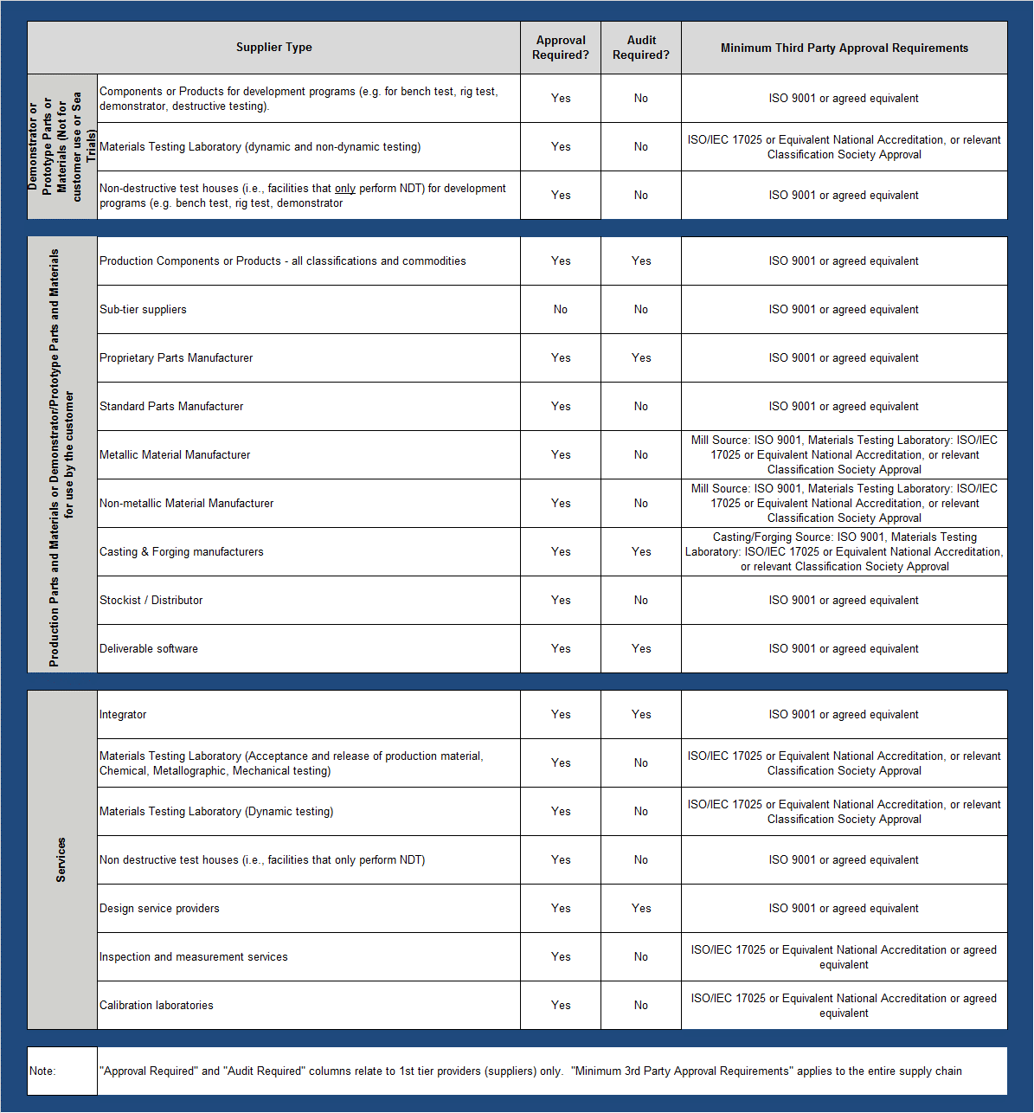

Appendix B – Minimum Document Retention Periods

Category A - Indicates the record will be retained for statutory or regulatory requirements. The minimum time period for a Category A record relating to products will be ten years after the product type is withdrawn from use

Category B - Indicates the record will be retained for business requirements. The retention period for Category B records will be six years however this may be adjusted based on the business requirement.

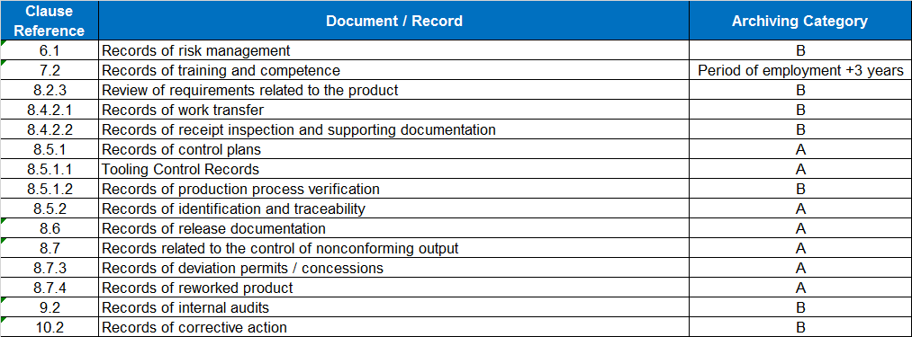

|  |  |  |  |  |  |
| --- | --- | --- | --- | --- | --- |
| Change History | | | | | |
| **Revision** | **Date** | **Description of Change** | **Author** | **Owner** | **Approval** |
| 1.2 | 25 October 2018 | Removal of references to Rolls-Royce | A. Wall | A. Wall | A. Wall |
| 1.1 | 19 June 2018 | Minor changes to add in link to forms and guidance as well as some corrections to the content including removal of record statement in various sections: Introduction, 7.1.3, 7.2, 8.2.3, 8.5.1.1 and Appendix B. | A. Wall | A. Wall | P. Adkins |
| 1.0 | 2 April 2018 | New edition to accommodate the latest changes to ISO9001:2015 | A. Wall | A. Wall | P. Adkins |
| **Document Update Policy**  This document may be updated periodically. Major updates will be indicated by an increase to a higher revision number (e.g., revision 1.0 to revision 2.0). Minor updates and corrections will be indicated by a decimal change in the revision number (e.g., revision 1.0 to revision 1.1). | | | | | |
|  | | | | | |

|  |  |
| --- | --- |
|  |  |