Fact sheet

AC Hybrid Solutions

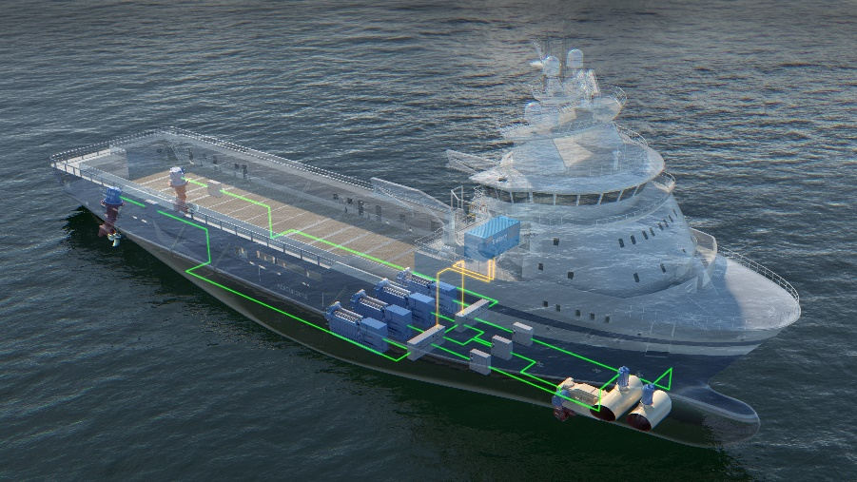
The demand for green solutions in the maritime industry is
driving an increased use of clean electrical power systems
that utilize flexible energy producers. Kongsberg Maritime
AC Solution is a scalable energy solution for conventional
power systems as well as complex systems
It can easily be integrated with the K-Pos system to achieve
unique additional energy savings

ENERGY SOLUTIONS PROPELLING THE SHIPPING INDUSTRY TOWARDS GREATER SUSTAINABILITY

AC Hybrid Solutions

About
Our mission is to help our customers lower the lifecycle cost and maximising return on investment in power systems. Our AC Hybrid solutions offers significant fuel efficiency gains, reduced emissions and an economically beneficial step towards a greener and cleaner environment.

Kongsberg Maritime offers solutions that includes a energy storage and energy control system. Our unique and patented energy control system for hybrid power systems extracts and shares information between all components in the digital power layer. Tight synchronized DP integration with load prediction delivers unique features.

The novel Hybrid energy control system includes Load Prediction and Inertia Control combined with conventional power management system functionality. Predictions of future thruster demand controls the energy production and energy storage charge / discharge. Load dynamics shared between the energy storage and producers ensures optimization for both producer limitations and energy storage lifetime.

Increased redundancy, performance and responsiveness, efficient operations and reduced maintenance are some of the other benefits.

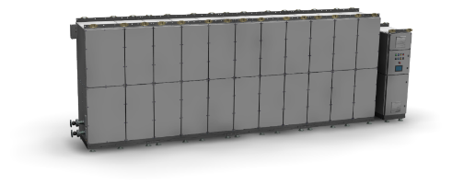

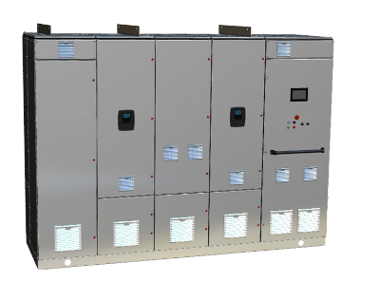

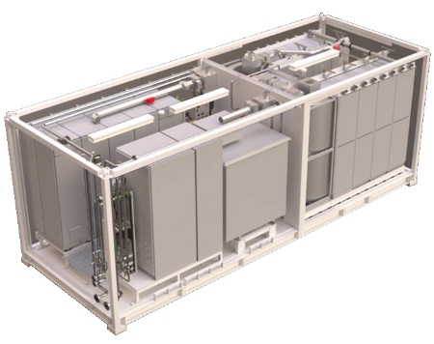

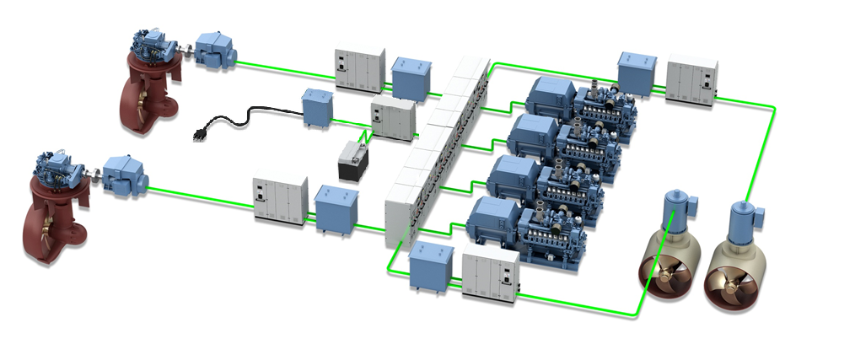

Energy Storage
In a AC Hybrid Solution energy storage is designed and implemented to increase peak loading capabilities on energy producers and avoid running of redundant energy producers.

Energy Storage main benefits:

• Limits load fluctuations which stabilizes the load of the power producer. (Peak Shaving)
• Provide instantly available power to compensate for sudden load steps. (Power Boost)
• Allows dynamic performance beyond ability of power producers (Performance Boost)
• Power plant utilization optimized for each operational mode and variable power required. (Flexible power production)
•Minimize redundancy running of power producers. (Spinning Reserve)
•Reduced environmental footprint through significant direct and indirect reductions of emissions
•Optimized power plant designs reducing overall cost of vessel construction (CAPEX)
•Enable optimized operation of the power plant, reducing running hours and maintenance as well as fuel and emissions (OPEX)
•Reduced engine stress, soothing, running hours, and extended maintenance intervals
Operational profile analysis services
To ensure an optimal solution for your vessels, KM will perform an Operational Profile Analysis that includes:
• Selecting optimal type of energy storage
• Calculating needed capacity
• May support to calculating potential fuel savings
• Simulation of vessel behavior in DP operation

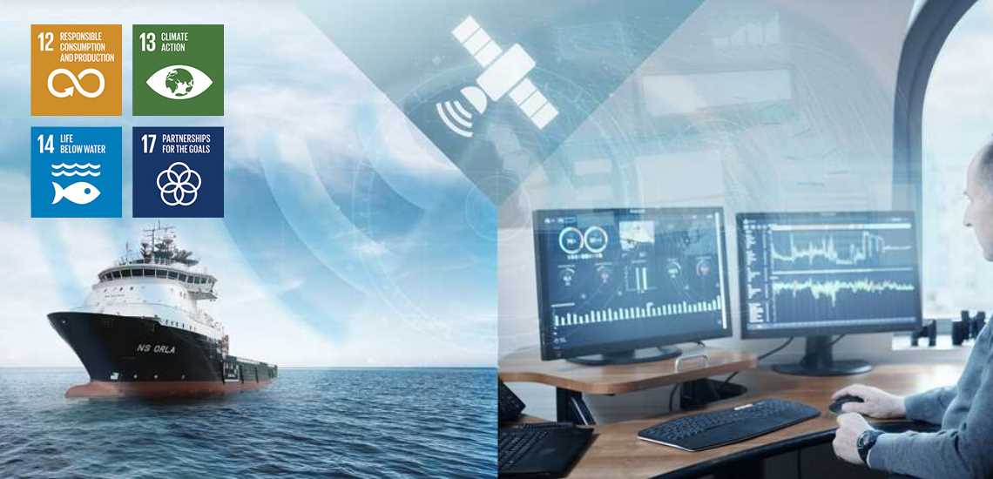

Energy Control

Kongsberg Maritime offers a solution that includes an energy control system to control the power flow and power sharing between power producers and energy storage. Our unique and patented energy control system for our AC Hybrid Solutions extracts and shares information between all components in the digital power layer. Tight synchronized DP integration with load prediction delivers unique features.

Core components of the novel Energy control includes load prediction and inertia control combined with conventional power management system functionality. Predictions of future thruster demand controls the energy production and energy storage charge / discharge. Load dynamics shared between the energy storage and producers ensures optimization for both producer limitations and energy storage lifetime.

The Energy Control uses the ESS to allocate power where it achieves most benefits. The interaction between the DP and the Energy Control makes its possible to provide power to thrusters and bus segments that will provide the most efficent use of the power to maintain the DP position. This also applies after WCFS where a energy producer or producer segment is lost. Then the Energy Control will instruct the ESS to provide power to the remaining segments and thrusters that will ensure the best position keeping capabilities

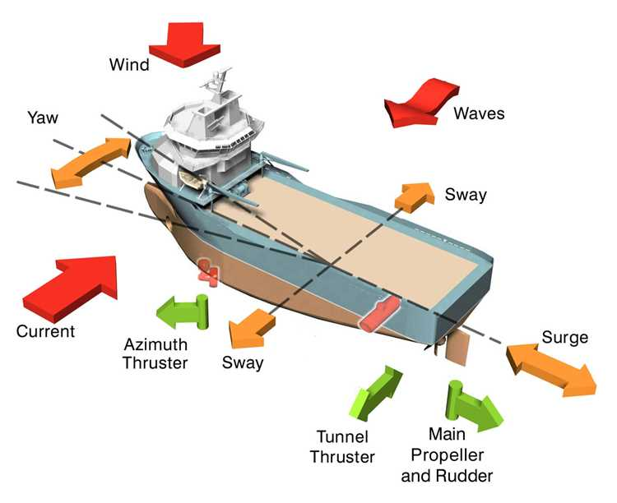

Another unique Energy Control function is “Power Boost”. This function allows for increased dynamic performance. When a vessel shifts position in DP operation, also known as “in field transit” or “repositioning” there can be a time window of power demand beyond the ability of the online energy producers.
Due to energy control DP integration, the ESS can be used for “power boosting” covering the temporally gap between available power and required power. The close interaction between Energy Control and DP secures positioning after WCFS in addition to having temporarily additional dynamic performance. This is possible due to our DP systems ability to differentiate power demand requirements in different stages of the DP operation and predict future loads and energy requirement.
The advantage of this compared to a conventional power management system is avoiding standby start of energy producers. Witch again gives reduced fuel consumption and reduced maintenance cost.

Energy Control main functions:
• Limits load fluctuations in order to stabilize the load of the producers (increases available power for propulsion and other processes)
• Load predictions used for improved handling of the load dynamics
• For DP vessels with required redundancy design:
• Minimum SOC is set based on the calculated DP requirement for the operation in case of worst single failure
• Looking at the total available inertia on the power plant in all different modes of operation. The DP will distribute the available inertia to all thrusters, matching the load ramps within the producers capability
• Energy Control ensures green operations by configuring zero emission modes with use of ESS and alternatively shore power

Modular design and benefits through integration
Hybrid Energy Control is designed with flexibility in mind and we offer optimized solutions for different vessel configurations:
• K-Pos and KM Energy Storage System (3rd party Power Management System)
• K-Pos, KM Energy Storage System, and KM PMS
The technological edge of AC Hybrid Solutions lies within the integration between the DP control system, power management system, and the energy storage system.
Additional benefits and functionality are unlocked as the integration between the KM products increases.

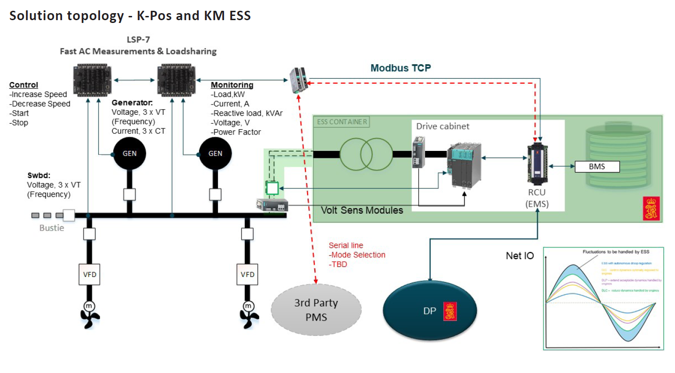

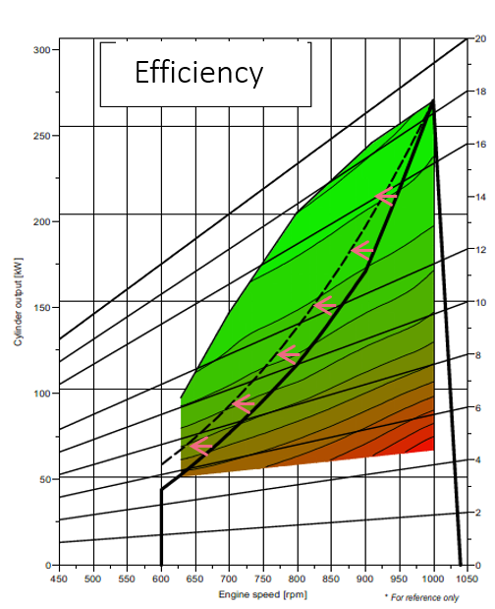
Figure 1 Efficiency Curve with energy control
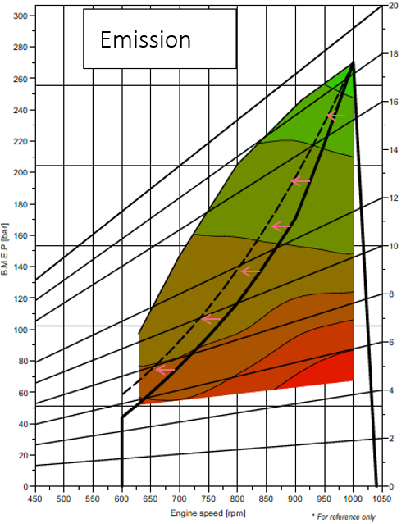
Figure 2 Emission Curve with energy Control

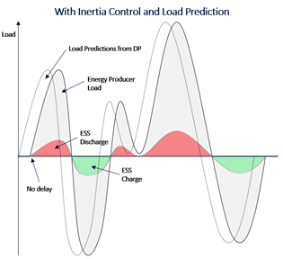
Figure 3 Energy Storage curve with Energy Control

“Full Picture” additional benefits
Our “Full Picture” benefits ensure operating energy producers in the most optimal way by reducing speed and shifting operational load limits with use of load prediction and energy control.
• Our Energy Storage implementation enables reduction of energy producers, hence increasing efficiency on remaining producers. In addition, our Energy Storage is only utilized when ramp and load demand is outside the producers capability or an energy producer is unexpectedly disconnected.
• Our Inertia Control with Dynamic Positioning System Integration, enable shift of load limit on energy producers by utilizing load prediction that will increase efficiency and reduce emission as shown in figure 1 and 2.
• With our “full picture” integration and load prediction, the energy producer speed can be increased before the load is applied, avoiding energy storage discharge as shown in figure 3, hence decreasing energy storage size requirement and increasing life due to less usage.
Hybrid Solutions Architectures
Kongsberg Maritime have a range of AC Hybrid Solutions Architectures to ensure that customers lower the lifecycle cost and maximising their investment in hybrid power systems. Our solution offers significant fuel efficiency gains, reduced emissions and an economically beneficial step towards a greener and cleaner environment. Below is a small selection of delivered Hybrid solutions Architectures.
Dedicated ESS solution (One)

Figure 4 One (1) ESS connected to one switchboard segment for Vessels classed with closed bus operation
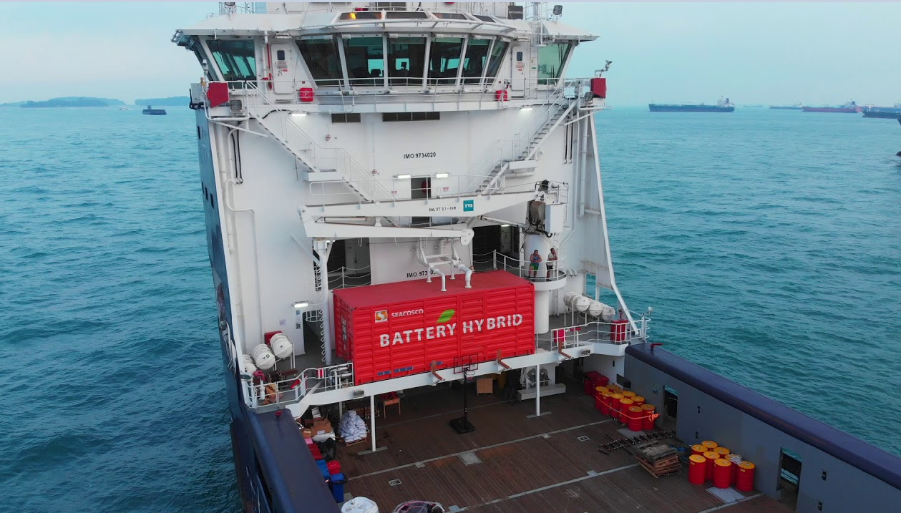

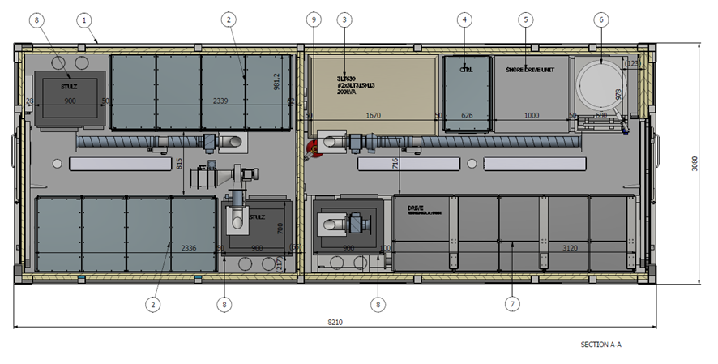

Dedicated ESS solution (Two)

Figure 5 One (1) ESS connected to each switchboard segment for vessels classed with open bus operation

Selectable ESS solution
Figure 6 One (1) ESS connected to selected one of two switchboard segments for vessels classed with closed bus operation

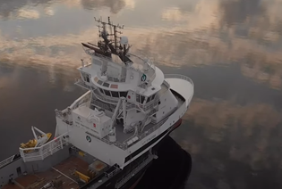

Power Assignment ESS

Figure 7 One (1) ESS connected to one (1) or two (2) switchboard segments for vessels operated with open or closed bus
PowerAllocator™
Figure 8 The PowerAllocator™ allows monitoring and allocation of power between redundancy groups even if bus-ties between main redundancy groups are open. Hence, proving benefits similar to operating with closed bus-ties between all redundancy groups, thus minimizing operational restrictions and increasing operational safety.

